Q1 . If , then the function is
- One –one only
- Onto only
- Both one –one and onto
- Neither one-one nor onto
Q2. The domain of definition of 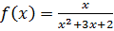 is
Q3. Let is a real valued function then its graph is
- A straight line passing through origin
- A straight line
- A straight line parallel to x-axis
- A straight line parallel to y-axis
Q4. 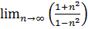 is equal to
- 0
- -1
- ½
- None of these
Q5. The value of 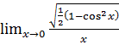
- 0
- -1
- 1
- None of these

Q6. The value of 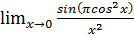 equals
- –
- 1
Q7. 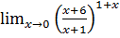 is equal to
- 6
- 5
Q8. 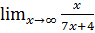 is equal to
- 0
- None of these
Q9. The function 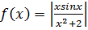 is
- Continuous everywhere
- Continuous at all points except zero
- Continuous at all points except at point -2
- Discontinuous
Q10. Let is a real valued function then
- The function is continuous at all points except zero
- The function is discontinuous
- The function is everywhere continuous
- The function continuous at all points except 2.

Q11. Find the domain of the function
- Set of real numbers
Q12. Find the range of the function
- Set of real numbers
Q13. Find 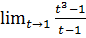
- 3
- 2
- 0
- Does not exist
Q14. Which of the following is true?
- is a continuous function.
- is a continuous function.
- is not differentiable at zero.
- All the above
Q15. Which of the following is false?
- Sum of two continuous function is a continuous function.
- A continuous function is always differentiable.
- A differentiable function is always continuous.
- sin is a continuous function.

Q16. Find the domain of the function
- [-5,5]
- (-5,5)
- (0,5)
- (0,5]
Q17. Find the domain of the function 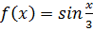
- Set of real numbers
- [-1,1]
- 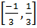
Q18. Let be a function given by then which of the following is correct?
- is one-one but not onto
- is onto but not one-one
- is one-one and onto both
- is neither one-one nor onto
Q19. Let be a function given by then which of the following is correct?
- is one-one but not onto
- is onto but not one-one
- is one-one and onto both
- is neither one-one nor onto
Q20. Find the domain of the real valued funcion 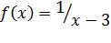
- Set of real numbers
- Set of real numbers except 3
- -
Q21. Find if
Q22. Find if
Q23. Find the range of the function
- [2,)
- (-]
- (0,)
- (-)
Q24. Find 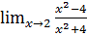
- 0
- 4
- ¼
- Does not exist
Q25. Find 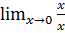
- -1
- 1
- 0
- Does not exist

Q26. Find 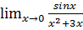
- 1
- 1/3
- 3
- 0
Q27. Let is defined by ,then
- is continuous everywhere
- is continuous at positive real numbers
- is discontinuous
- is continuous everywhere except at zero.
Q28. Let , then which of the following is true?
- are the points of discontinuty.
- Only 0 is the point of discontinuity.
- Only 1 and 2 are the points of discontinuity.
- It is continuous everywhere.
Q29. Which of the following is true
- Sin|x| is a continuous function.
- |x| is differentiable at 0.
- xsinx is not a continuous function
- |sinx| is not a continuous function.
Q30. Find if
- 2
- 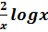

Q31. Find if
- 0
- 1
Q32. Find if
- 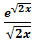
Q33 . Find if
- 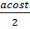
- 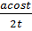
- 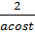
Q34. Find if
- 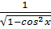
- 0
- -1

Q35. Find if 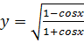
- 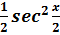
- 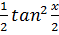
- 2